Title:
“Child led disaster risk reduction and Climate change intervention in coastal Andhra Pradesh”

Background:
In 1977 at Divi Seema cyclone innumerable children died and it was a tragic event in the history of disasters. The family members who were able to swim kissed their family children saying goodbye and left them in the water abruptly as the children are obstacles to swim to survive their lives. Mr.Veerayya who is the resident of Ramakhandam village revealed his situation in that disaster. He also left his 5 years male child named sambhasivarao in the water and started swimming to save his life at least!! After moving two yards in the water he turned his head to have last look on his son. Sambhasivarao was drowning in the water moving his hands and the father also saw a thatched roof floating on the water at the same time. He went back to his son and lifted his son’s hair and put him on the thatched roof along with him.
They floated in the water for 6 hours and find a tree in the water. They (both) climbed the tree and stayed at a tree branch for 15 hours. After receding the water flow \,they got down and walked for 25 kilometers to reach the cyclone shelter. This live story is still available in Ramakhandam village near Machilipatnam Krushna district. The son name Mr.Sambha sivarao has been renamed it as ‘Mruthyunjayarao” (Conqueror of death in English) after this incident.
1002 students died in the 2001 Bhuj Earthquake. 1884 school buildings- collapsed loss of 5950 classrooms, 11761 school buildings suffered major to minor damages.
Kumbakonam fire tragedy …… A deadly fire raged through Lord Krishna School killed 93 children, all below the age of 11 years. Let us learn lessons from earlier tragedies & make our schools a safer place for children.

Intervention on Child led disaster risk reduction has been initiated in 2008 and it is still going on in all the schools and communities.
The intervention has been initiated in 25 vulnerable schools and 25 communities in East Godavari district of Andhra Pradesh India. East Godavari District, one of the nine coastal districts of Andhra Pradesh, is a regular victim of multiple disasters and this district was badly affected by all major natural disasters time to time since independent era. Fishing community is the main victim of all disasters and all the families dwell nearby to “Bay Of Bengal” at one or two kilometers distance from the sea. Their main occupation is fishing and it is a routine responsibility of a fisherman for livelihood that goes to fishing at early hours and comes back to home afternoon at 2 pm / 3 pm. They do not have RCC buildings which can resist the cyclone wind velocity and live in thatched houses. These conditions make them more vulnerable to natural disasters.
Preparedness measures at community level are nil and vulnerable communities i.e. Children, Aged, Women, Physically Challenged, Mentally Retorted, Pregnant Women and Infants are mostly the worst victims of any disaster.
In 1996 cyclone, as many as 217 children, 62 aged people, 8 pregnant women, 28 physically challenged persons were died at Magasanitippa Village which is located nearby to sea, because of lack of preparedness measures especially lack of pre planned evacuation plan.

Who all the actors involved (accurate rendering of people, institutions, etc.)?

- 28,412 children and 36,116 adults from 25 disaster prone villages and 25 vulnerable schools.
- District education Department
- District Fire department
- Mandal Revenue Office
- Mandal development office
- District Fisheries office
- 150 Teachers from 25 vulnerable Schools
- State disaster management authority
- District women and child welfare department

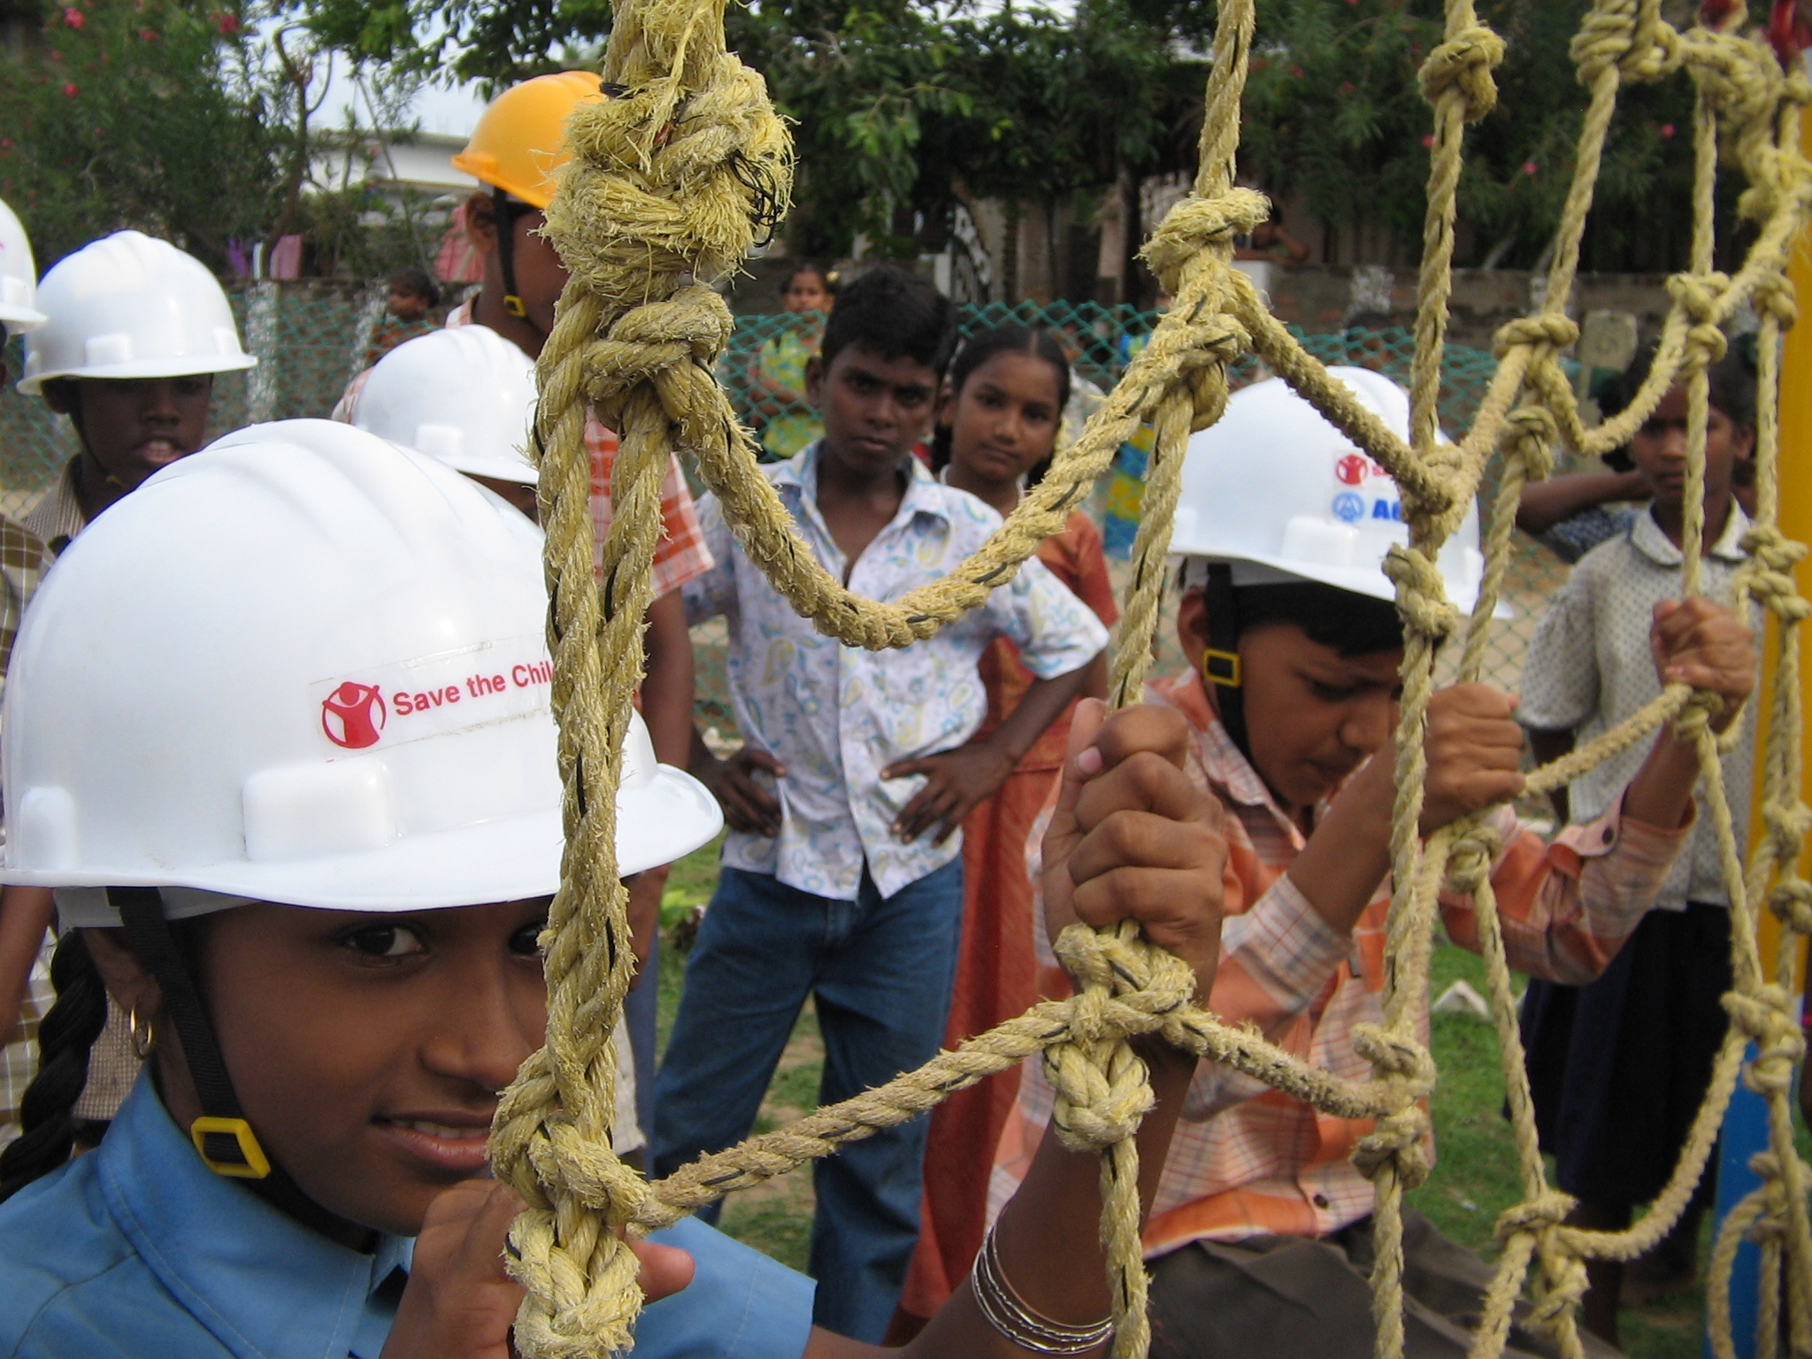
Children are practicing to climb the Rope Bridge to rescue.
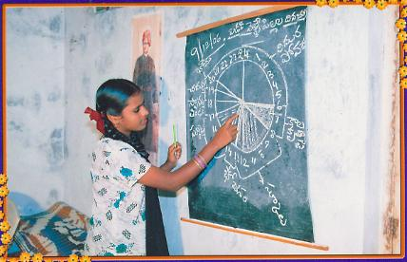 School going child is explaining disaster cycle.
Why is this good practice?
- The project is a model to all the vulnerable communities in the country and children studying in vulnerable schools.
- Capacities of vulnerable communities are increased and confident of combating the disaster situations.
- Dependency on outside people, like Police, Medical teams, Military for rescue and Medical aid has been reduced drastically.
- Relief measures to be taken up in the event of disaster are taken care of by Taskforce groups, not depending on outside help.
- Able Bodied persons in vulnerable villages have specific responsibilities and actions in pre-during-post disaster situations.
- Women are very active and 50% of women are involved in each taskforce team.

What have been the key success/failure factors of this initiative?
CADME /ACTION has initiated community based d Disaster Preparedness Program at vulnerable villages and child led disaster risk reduction at vulnerable schools of east Godavari district in the year 2008 and as a result of these interventions as many as 30 taskforce groups at community level and 25 child led taskforce groups at vulnerable schools level have been formed.

- All the 30 taskforce groups at village level are capacitated to combat the disaster situations (pre, during and post) with specific roles and responsibilities in each situation.
- Perfect planning is done before any disaster, predicted and warning given by metrological department.
- Disaster drills are organized at regular intervals to familiarize them with their taken tasks and responsibilities.
- Contingency plans are updated every two months.
- Local bodies of each village have taken into consideration of the work done by task force group at their respective villages.
- Contingency plans developed by taskforce groups have been approved at local, mandal & district levels for spontaneous actions in collaboration with government officials for quick response.
- A joint taskforce committee consists of local task force and government officials at panchayat level, mandal level and district level have been formed to address the problems and to make spontaneous actions in the event of disaster. Selective government officials based on their interest and commitment have also undergone for Disaster Preparedness trainings conducted by CADME /ACTION.
- Five important teams are formed
- Emergency medical care team
- Emergency rescue team
- Relief camp management team
- Warning and evacuation team
- Water and sanitation team
What are the innovative elements and results?
INNOVATIVE ASPECTS:
- Horizontal trainings by trained taskforce members in other vulnerable villages are conducted on their own initiation.
- School safety maps are developed by trained children in other vulnerable schools in consultation with the respective children and children in other schools are trained by trained children.
Cost Effectiveness:

- There is no need to purchase anything form outside to implement this initiative at vulnerable villages.
- Task force groups are well versed through the training and how to prepare the floating raft, using the local material like, gunny bags, damaged wooden flanks, waste glass bottles, and torned saris and so on.
- They are also trained to use waste cloth to be used as bandages for chin, knee head injuries and chest arm and leg fractures.
- They also construct a floating aid which can rescue two drowning persons with two plastic pots and a rope.
- The entire training can be organized with very less Expenditure and amount that we are investing on this, will give a great result in their community.

What have been the city / local government contribution to reducing disaster risks and vulnerabilities?

Local Panchayaths of 30 villages have been extending hundred percent cooperation in all aspects. i.e. negotiating with all government line departments, financial assistance to provide the food to resource persons, resolutions on involvement of local people in disaster times and so on.

SCHOOL based DRR:
Disaster preparedness club in schools:

Before we started our work we got the formal permission from the Education Officer in the District.
We started disaster preparedness clubs in 15 schools in the project villages. Each Club comprises of 100 children from 7-10 standard. Regular classes on DRR are conducted by the Cluster Coordinators outside the school hours (4.30 – 5.30 pm twice a week). The selection of children and leaders among them was done in participatory method involving children.
We have been using a training manual for the training purposes. The trainings in each school are tailor made to address vulnerability of that particular school. The training focuses on peace time issues or emergencies like harms of pesticides and how to protect from it, types of fire and their response, responding to any accidents or children falling etc.
To help in better information transaction we have placed a drop in box in each school so that students or club members are using it to ask doubts or clarification and to give their suggestions. These children are an asset to the village community too as they have basic knowledge on disaster preparedness. The emphasis is on clarity on concepts, role of each member in the group and on horizontal training or information dissemination to children in school and in their villages. The clubs are now involved in risk mapping keeping in mind the both natural and man made hazards
Importance is given on the need for horizontal transfer of knowledge so as to cover many children. To reach out to other children in the school, the trained children perform disaster drills in their own schools every quarter and also during the school assembly or any special school programs, on disaster preparedness. The trained children with the support of the teachers organise training to other students to organize disaster preparedness drills and also help them in increasing their knowledge on disasters by organizing quiz and essay writing competitions.
Child protection in the schools to build awareness on Child protection issues is done on regular intervals among the club members.

Formation of cultural troupes:

Cultural troupes are formed in schools with 3 children from each school trained intensively. The cultural troupe consisting of club members use songs, skits and stories to effectively disseminate information in schools and nearby villages.
Trainings for teachers from 100 schools:
One of the keys to success of school level program is trained and motivated set of teachers in each school. 200 teachers 100 schools have undergone for CLDRR and child rights and child participation.

COMMUNITY DRR:

a. Training of trainers:
75 people from 25 villages have undergone for training on CLDRR and have been supporting the staff at the village level for training the task force groups.

Module for trainings:
- Development and Disaster preparedness
- Disaster history of each vulnerable village
- Emergency medical care
- Emergency rescue
- Relief camp management
- Contingency plan development
- Training skills
- Children’s participation and Child protection

Task force groups:
The task force groups are formed in 25 villages.. Each group consists of 50 people i.e 20 children and 30 adults. The groups are now started activities in their respective villages like vulnerability mapping of the village, regular skill trainings in groups.

Grain Banks:
As part of CLDRR program we have introduced Grain bank program in all the project villages. During cyclones, floods and other disasters people lose assets and livelihood options and need to stay without food for several days. This was seen widely during the recent floods in the project villages. The village community during the last year has been discussing a plan like this which will help them to take care of them selves during the initial days of disasters. Keeping this point in view a grain banks have been established in all the 25 villages.

ADVOCACY:

a. Advocacy and media training for children:

30 children underwent for media training and these children who are part of the training program are playing an active role in advocacy efforts..

b. Consultation meeting with I/NGOs at the state level:
In order to influence policies and practices of the Government and to build constituency to have a shared understanding on the inclusion of children’s needs and concerns in disaster management policies, Trained children have organised a consultation meeting with I/NGOs at the state level. The participants were primarily be agencies involved in emergency response and Government officials. The consultation was able the participants to have a shared understanding on the inclusion of children needs and concerns into the state disaster management plans.
Workshop with Education department officials:
Workshops with the department and regular one to one meetings have been organised at regular intervals in getting the officials to understand and support the need for inclusion of disaster preparedness in school curriculum and for disaster preparedness clubs in schools.
Lessons Learned:

- It is very important to be flexible and pay patience in under to survive and grow the structures (Task groups) developed at community and school levels.
- Admit to mistakes and correct them.
- Let the Taskforce take their own decisions in the event disaster whether it is right or wrong.
- Be flexible with Taskforce members and learn what they say.

CHALLENGES:
- Initially there was no response from the government as well as from the local communities.
- Having approved the contingency plans and school safety maps has been a challenge.
- Motivating the community and children towards the intervention is another challenge.
- Owning of the intervention by the community and children is another challenge.

How to improve similar initiatives in the future?
The similar intervention can be implemented in other villages improving the above mentioned challenges involving the trained children and Task force groups of this project. District officials and other stakeholders of disaster management are quite impressed of this intervention and started replicating it in other vulnerable villages and schools. Hence the above mentioned challenges are now opportunities to future initiatives.

How easy would it be to replicate this practice elsewhere?
As mentioned above this intervention can be replicated any part of the world at vulnerable village or school based on the type of disaster but same methodology can be adopted for any type of disaster.
How could the practice be replicated in a different context?
This can be replicated to any context either for Tsunami prone or cyclone prone or flood prone or flash flood prone or fire accident zone or in a peace time.
What would be the economic and political constraints to scaling-up?
There is no political constraint to implement the project but financial constraints are there. As the governments do not have funds to initiate this kind of interventions, it inevitable to search for funding elsewhere to scale up the project.
About the Author
Name : Meda Gurudutt Prasad
Profession : Disaster Manager, CADME, (Costal area Disaster mitigation efforts)

Experience : 28 years in development sector
Telephone No : 91 883 2461442
Fax No : 91 883 2468449
Email : prasad.org@rediffmail.com
cadmeindia@rediffmail.com
Website : www.cadmeindia.org
Qualification: Postgraduate in Social Work from Andhra University and Diploma In HELP from Hawaii University (USA)

International Trainings Attended:
1993 | Community Empowerment through Cooperatives | Tel Aviv | Israel
1994 | Disaster Management Course – 18 | Bangkok | Thailand
2003 | International Award on Early warning | Bonn | Germany
2005 | UN-ISDR Workshop on Best Practices of Disaster Management. | Geneva | Switzerland
2006 | International Conference on Disaster Medicine | TOKYO | JAPAN
2009 | International conference on Building a Local Government Alliance for Disaster Risk Reduction | Incheon | Korea.
Awards:
1. “Gold Medal” awarded by CDA Bangalore for outstanding performance in Emergency Preparedness written and oral test.
2. United Nations “SASAKAWA AWARD” International Strategy for Disaster Reduction (ISDR).

